Lab 3 – Traversing/DOM
Lab 3-1

Use children( [selector]) to turn list item 1 to 3 to red color and use siblings( [selector] ) to turn list item 4 to 6 to blue color. Use the following codes as part of your program.

<style>
.selected_red { color:red; }
.selected_blue { color:blue; }
</style>
<div>
<ul class="red">
<li>list item 1</li>
<li>list item 2</li>
<li>list item 3</li>
</ul>
<ul class="blue">
<li>list item 4</li>
<li>list item 5</li>
<li>list item 6</li>
</ul>
</div>

Lab 3-2

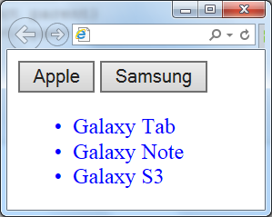
Write a program to display two buttons on the browser, as shown in the figure.
When Apple button is clicked, following items are displayed in red color:
- iPhone
- iPad
- iPod
When Samsung is clicked, following items are displayed in blue color instead:
- Galaxy Tab
- Galexy Note
- Galaxy S3

Lab 3-3

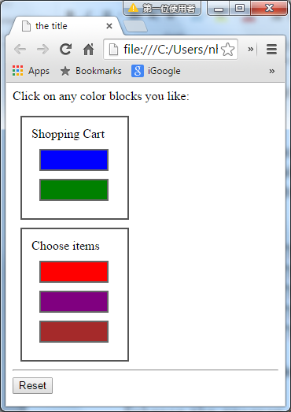
Write a program to input items into a Shopping Cart as shown in the figure.

At the beginning, the Shopping Cart is empty. When you click an item, the item will be put inside the Shopping Cart. The five blocks are constructed as below:

<body>

<div class="div" style="background-color:blue;"></div>

<div class="div" style="background-color:green;"></div>

<div class="div" style="background-color:red;"></div>

<div class="div" style="background-color:purple;"></div>

<div class="div" style="background-color:brown;"></div>

</body>

Reset button will put all items back into the lower block.

Hints: Use appendTo(selector), location.reload();

* Enhance the program such that the items in the Shopping Cart will go back to the lower block when clicked.

Lab 3-4
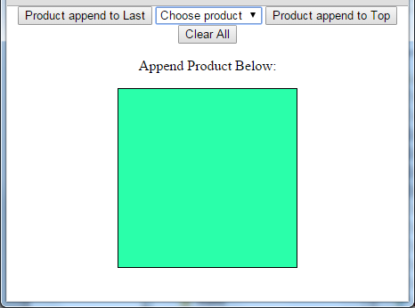
Write a jQuery program to choose the name of devices from a dropdown box* into the green below as shown in the figure.
There are 3 buttons. One is used to append the device to the end of the list. Another button appends the device to the top of the list.
Besides, a Clear All button is used to clear the list and restart the program again.
*Dropdown box: <select id="product">
<option value="white">Choose product</option>
<option value="Desktop">Desktop</option>
<option value="Notebook">Notebook</option>
<option value="iPad">iPad</option>
<option value="iPhone">iPhone</option>
<option value="Tablet">Tablet</option>
</select>
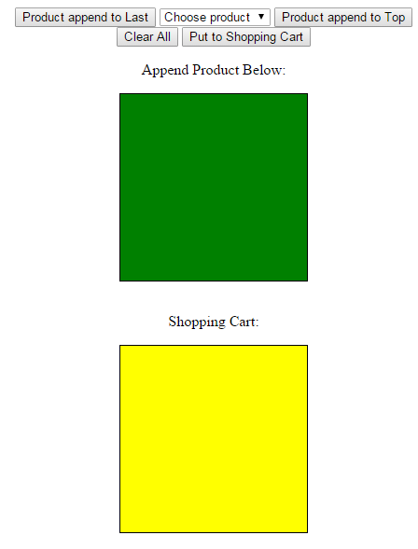
Lab 3-5
In addition to Lab 3-4, a shopping Cart is added as shown in the figure.

A new button is added to put the product list into the shopping cart box below.
At the beginning, you add the products in the upper box, then put them into the box below. Afterwards, you may clear all the boxes and then redo the operations again.

Given:
<style type="text/css">
body{margin:10px;}
#div1 { border:1px solid;height:200px;width:200px;background-color:green;}
#div2 { border:1px solid;height:200px;width:200px;background-color:yellow;}
</style>
<body>
<center>
<input type="button" id="append" value="Product append to Last" />
<select id="product">
<option value="white">Choose product</option>
<option value="Desktop">Desktop</option>
<option value="Notebook">Notebook</option>
<option value="iPad">iPad</option>
<option value="iPhone">iPhone</option>
<option value="Tablet">Tablet</option>
</select>
<input type="button" id="prepend" value="Product append to Top" />
<input type="button" id="clear" value="Clear All" />
<input type="button" id="update" value="Put to Shopping Cart" /><br />
<p>Append Product Below:</p>
<div id="div1"><span></span></div><br/>
<p>Shopping Cart: </p>
<div id="div2"><span></span></div>
</center>
</body>

